Tasks Related to Jenkins Pipelines
- Create one Declarative pipeline job
Source Code:https://github.com/betawins/spring3-mvc-maven-xml-hello-world-1.git

1. Jenkins Declarative Pipeline
Create a Pipeline job in Jenkins and use the following Jenkinsfile:
pipeline {
agent any

tools {
maven 'MVN_HOME'
jdk 'JDK17'
}

environment {
APP_NAME = 'ncodeit-hello-world'
APP_VERSION = '3.0'
}

stages {

stage('Clone Code') {
steps {
echo 'Cloning source code...'

git branch: 'master',
url: 'https://github.com/krishnasanthosh6160/spring3-mvc-maven-xml-hello-world-1.git'
}
}

stage('Verify Environment') {
steps {
sh '''
echo "===== Java Version ====="
java -version

echo "===== Maven Version ====="
mvn -version

echo "===== POM ====="
grep -E '<groupId>|<artifactId>|<version>|<packaging>' pom.xml
'''
}
}

stage('Maven Build') {
steps {
echo 'Building application using Maven...'

sh '''
mvn clean install \
-Dmaven.test.failure.ignore=true
'''
}
}

stage('Verify WAR') {
steps {
sh '''
echo "===== Generated WAR ====="
ls -lh target/

test -f target/*.war
'''
}
}

stage('Publish to Nexus') {
steps {
echo 'Publishing WAR artifact to Nexus...'

nexusArtifactUploader(
nexusVersion: 'nexus3',
protocol: 'http',
nexusUrl: '100.31.118.142:8081',
groupId: 'com.ncodeit',
version: '3.0',
repository: 'maven-releases',
credentialsId: 'nexus-credentials',
artifacts: [
[
artifactId: 'ncodeit-hello-world',
classifier: '',
file: 'target/ncodeit-hello-world-3.0.war',
type: 'war'
]
]
)
}
}
}

post {
success {
echo "Pipeline completed successfully for ${APP_NAME}:${APP_VERSION}"
}

failure {
echo "Pipeline failed for ${APP_NAME}:${APP_VERSION}"
}

always {
echo 'Pipeline execution completed.'
}
}
}

Configure Maven and JDK in Jenkins
Go to:
Jenkins → Manage Jenkins → Tools
Configure:
JDK
Name: JDK17
If you're using a system-installed JDK, you can alternatively configure its installation path.
Maven
Name: MVN_HOME
Enable Install automatically and select an appropriate Maven version.
The names must match the names used in the Jenkinsfile: JDK17 and Maven.

Create the Jenkins Pipeline Job
Go to:
Jenkins → New Item
Enter:
Name: spring3-mvc-maven-pipeline
Select:
Pipeline
Click OK.
Under Pipeline:
Definition: Pipeline script
Paste the Jenkinsfile above.
Click:
Save → Build Now

Pipeline Flow
The job will execute:
Checkout
↓
Build
↓
Test
↓
Archive WAR
The Maven command:
mvn clean package -DskipTests
will generate the WAR under:
target/
Then the test stage runs:
mvn test
Finally Jenkins archives:
target/*.war

Expected Jenkins Console Output

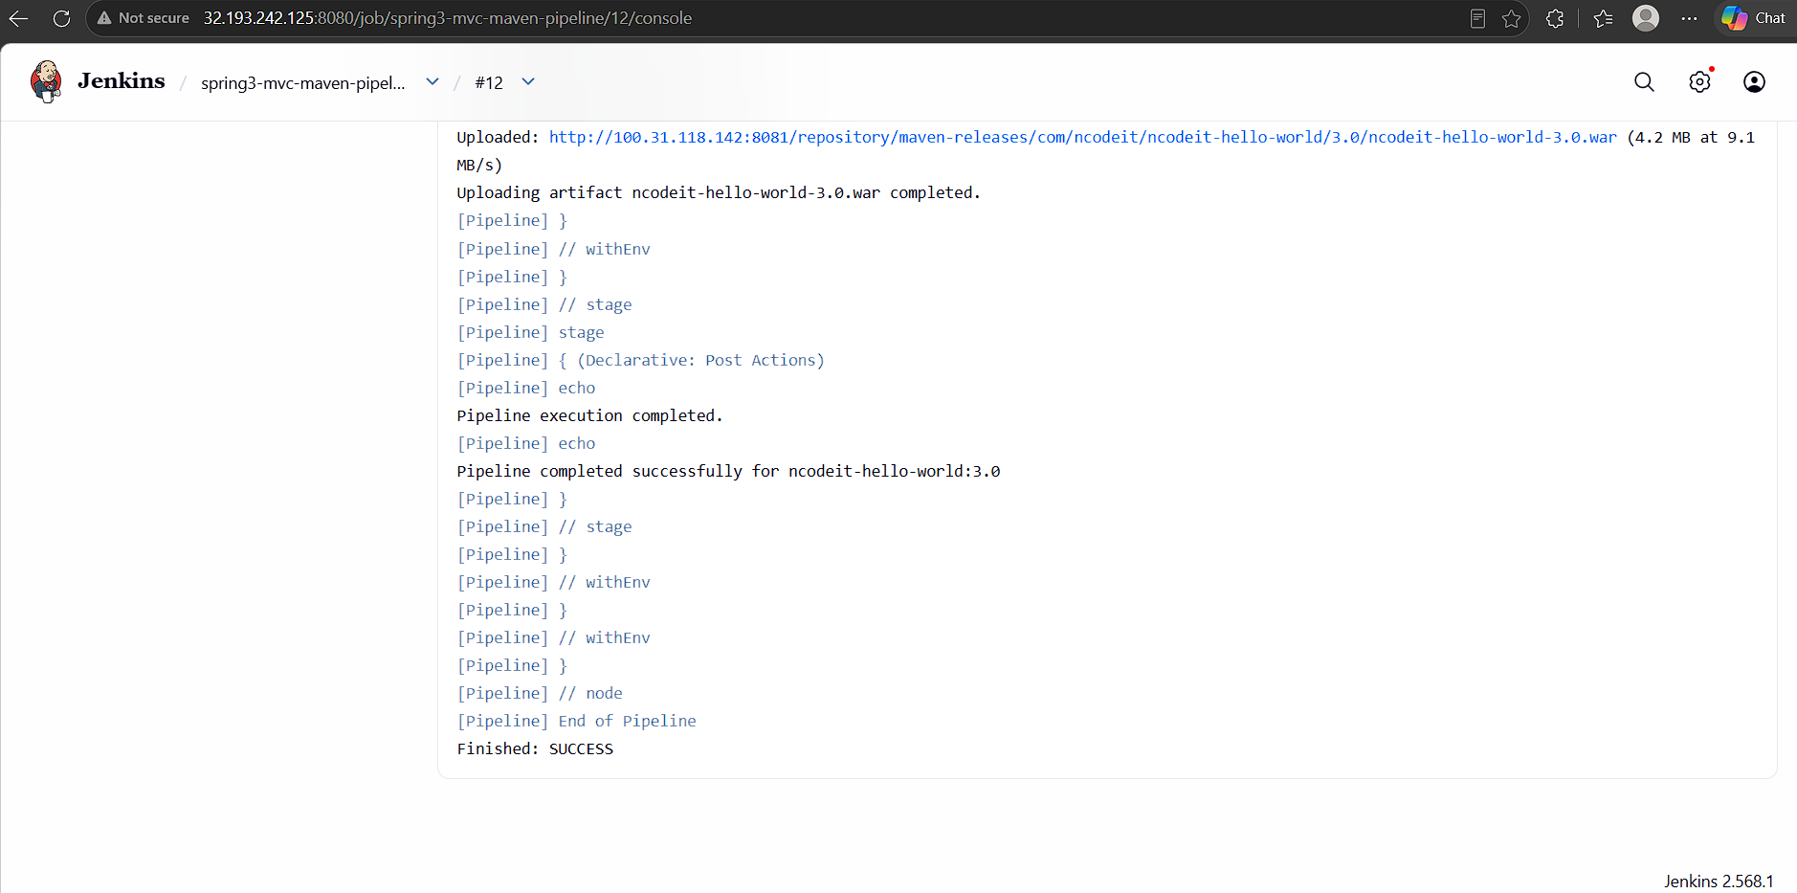
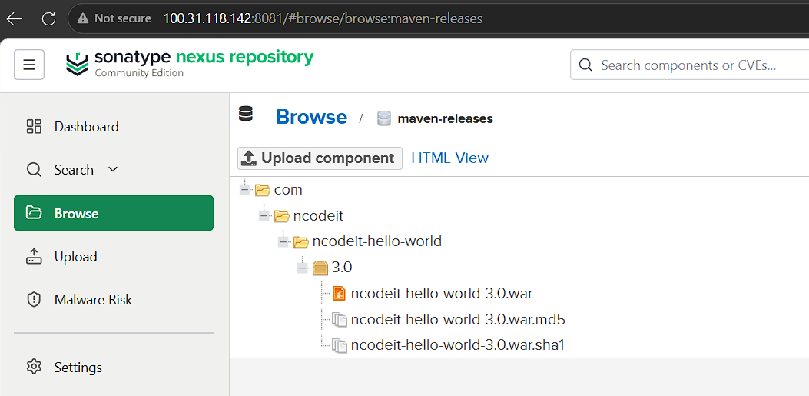
- Create one Scripted pipeline job
Source Code:https://github.com/betawins/spring3-mvc-maven-xml-hello-world-1.git

Jenkins Scripted Pipeline uses Groovy-style syntax, typically with a node {} block, and stage blocks are recommended for clear visualization in Jenkins.

Create the Scripted Pipeline Job
Go to:
Jenkins → New Item
Enter:
spring3-mvc-maven-scripted
Select:
Pipeline
Click OK.
Under Pipeline:
Definition: Pipeline script
Then paste the following Scripted Pipeline.

node {
def mvnHome
stage('Preparation') {
echo 'Checking out source code from GitHub...'
git branch: 'master',
url: 'https://github.com/krishnasanthosh6160/spring3-mvc-maven-xml-hello-world-1.git'
echo 'Getting Maven tool configured in Jenkins...'
mvnHome = tool 'MVN_HOME'
echo "Maven Home: ${mvnHome}"
}
stage('Verify Environment') {
echo 'Checking Java and Maven versions...'
sh """
echo "===== JAVA VERSION ====="
java -version
echo "===== MAVEN VERSION ====="
${mvnHome}/bin/mvn -version
"""
}
stage('Build') {
echo 'Building application using Maven...'
sh """
${mvnHome}/bin/mvn \
-Dmaven.test.failure.ignore=true \
clean package
"""
}
stage('Verify Artifact') {
echo 'Checking generated WAR file...'
sh '''
echo "===== TARGET DIRECTORY ====="
ls -lh target/
echo "===== WAR FILE ====="
ls -lh target/*.war
'''
}
stage('Publish to Nexus') {
echo 'Publishing WAR artifact to Nexus...'
script {
// Read required Maven information directly from pom.xml
def groupId = sh(
script: "grep -m1 '<groupId>' pom.xml | sed 's/.*<groupId>\\(.*\\)<\\/groupId>.*/\\1/'",
returnStdout: true
).trim()
def artifactId = sh(
script: "grep -m1 '<artifactId>' pom.xml | sed 's/.*<artifactId>\\(.*\\)<\\/artifactId>.*/\\1/'",
returnStdout: true
).trim()
def packaging = sh(
script: "grep -m1 '<packaging>' pom.xml | sed 's/.*<packaging>\\(.*\\)<\\/packaging>.*/\\1/'",
returnStdout: true
).trim()
def pomVersion = sh(
script: "grep -m1 '<version>' pom.xml | sed 's/.*<version>\\(.*\\)<\\/version>.*/\\1/'",
returnStdout: true
).trim()
// If packaging is not specified, Maven default is jar
if (!packaging) {
packaging = 'jar'
}
echo "Group ID : ${groupId}"
echo "Artifact ID : ${artifactId}"
echo "Packaging : ${packaging}"
echo "POM Version : ${pomVersion}"
// Find generated artifact
def artifactPath = sh(
script: "find target -maxdepth 1 -type f -name '*.${packaging}' | head -1",
returnStdout: true
).trim()
if (!artifactPath) {
error "Artifact could not be found in target directory."
}
echo "Artifact Path: ${artifactPath}"
nexusArtifactUploader(
nexusVersion: 'nexus3',
protocol: 'http',
nexusUrl: '100.31.118.142:8081',
groupId: groupId,
version: "${BUILD_NUMBER}",
repository: 'ncodeit-scripted',
credentialsId: 'nexus-credentials',
artifacts: [
[
artifactId: artifactId,
classifier: '',
file: artifactPath,
type: packaging
],
[
artifactId: artifactId,
classifier: '',
file: 'pom.xml',
type: 'pom'
]
]
)
echo 'Artifact successfully uploaded to Nexus.'
}
}
echo '========================================='
echo 'Scripted Pipeline completed successfully.'
echo '========================================='
}
Pipeline execution flow
Your Scripted Pipeline will execute:
GitHub
|
↓
Clone Code
|
↓
Verify Environment
|
↓
Maven Build
|
↓
Verify WAR
|
↓
Archive Artifact
|
↓
SUCCESS

Expected console output

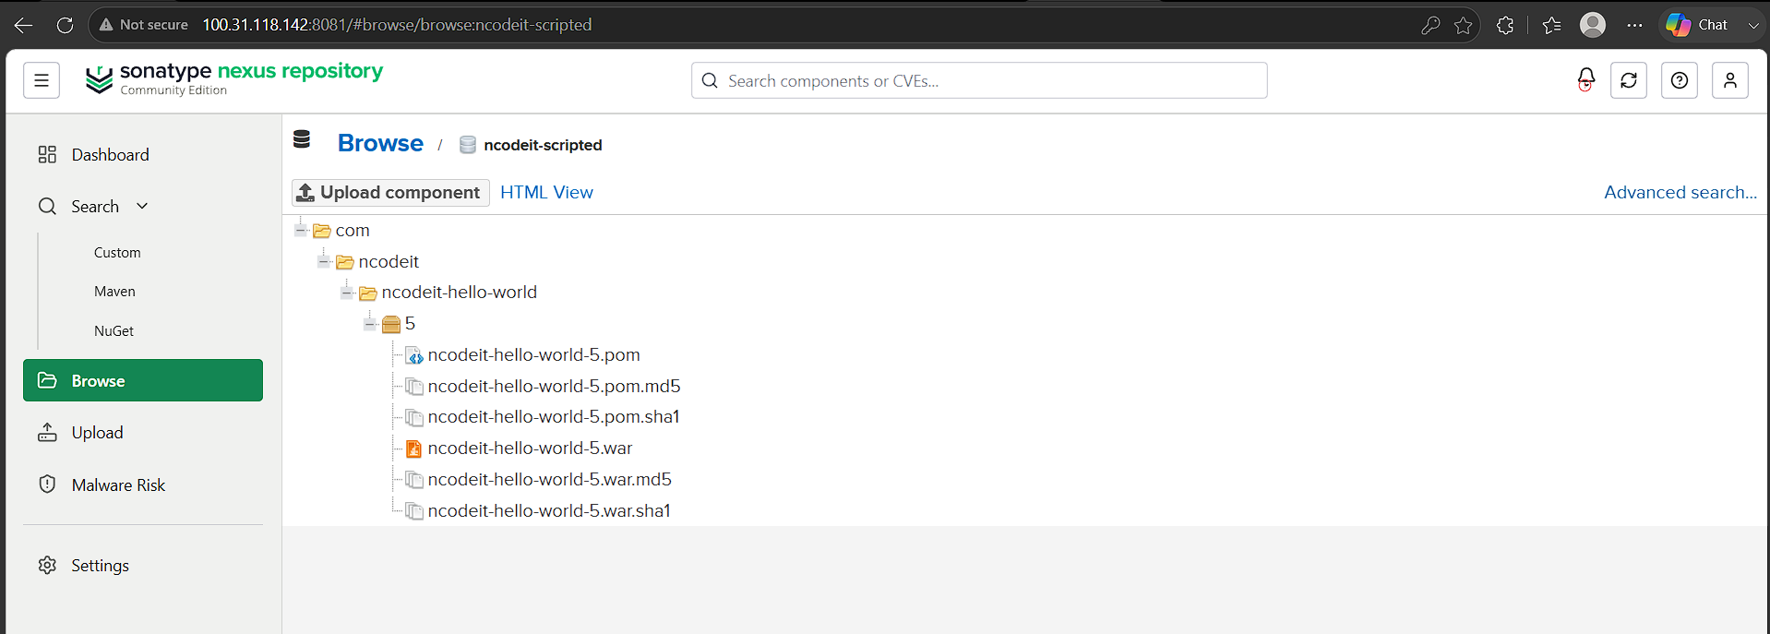
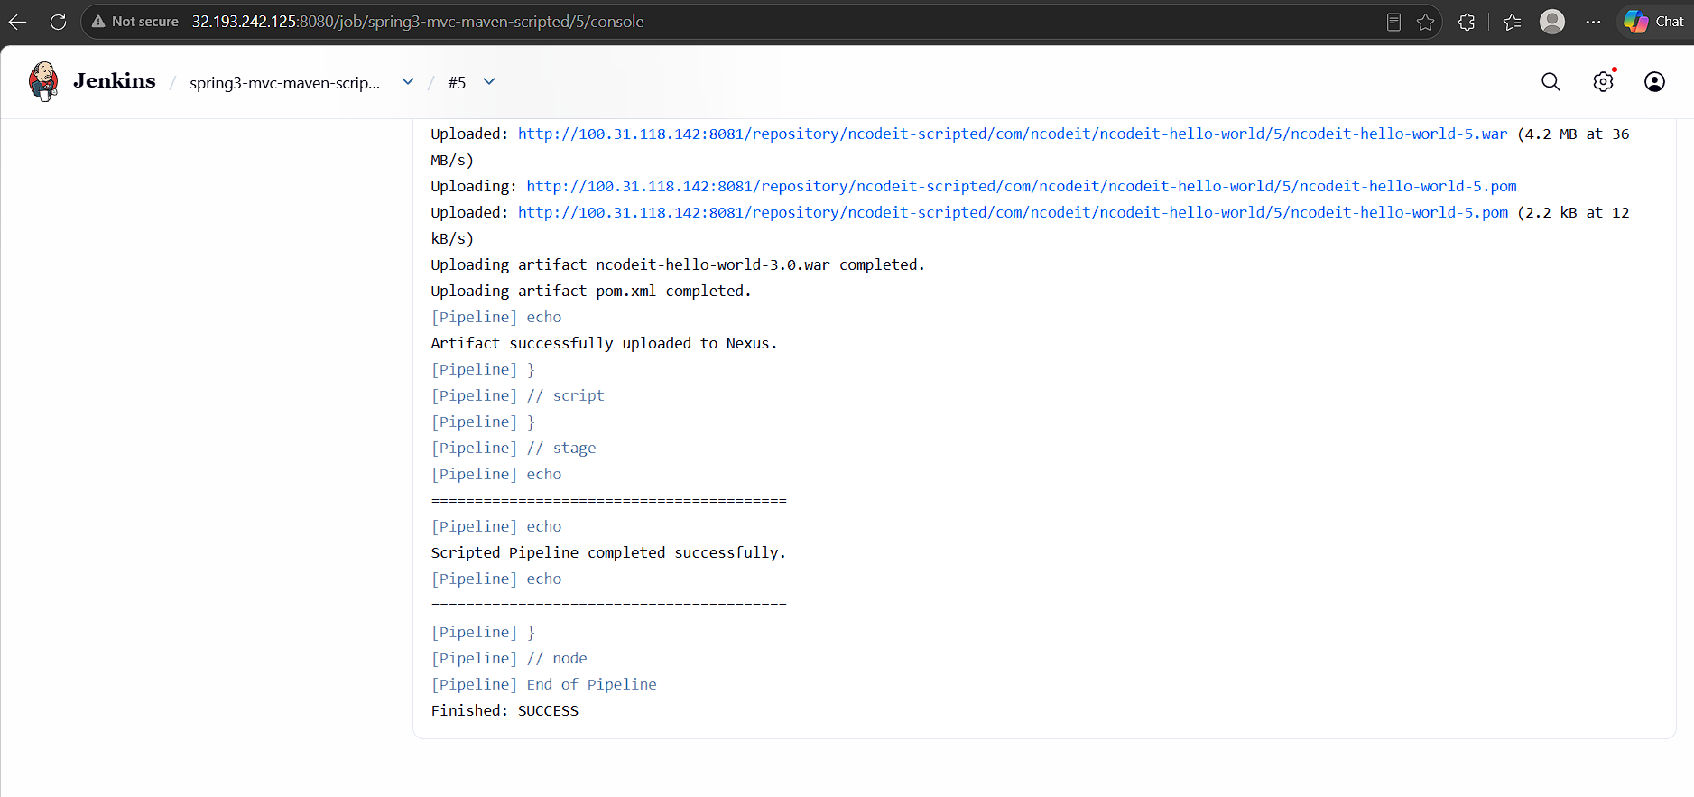
- Create one Parameterized job
Source Code:https://github.com/betawins/spring3-mvc-maven-xml-hello-world-1.git
Create the Jenkins Job
Go to:
Jenkins → New Item
Enter:
spring3-mvc-maven-parameterized
Select:
Pipeline
Click OK.
Under Pipeline → Definition, select:
Pipeline script

pipeline {
agent any
parameters {
choice(
name: 'BRANCH',
choices: ['master'],
description: 'Select the Git branch to build'
)
booleanParam(
defaultValue: false,
description: 'Build the Maven application',
name: 'mvn_build'
)
booleanParam(
defaultValue: false,
description: 'Publish the artifact to Nexus',
name: 'publish_to_nexus'
)
}
tools {
// Must match your existing Jenkins Maven installation
maven 'MVN_HOME'
}
environment {
NEXUS_VERSION = 'nexus3'
NEXUS_PROTOCOL = 'http'
NEXUS_URL = '100.31.118.142:8081'
NEXUS_REPOSITORY = 'ncodeit-helloworld'
NEXUS_CREDENTIAL_ID = 'nexus-credentials'
}
stages {
stage('Clone Code') {
steps {
echo "Selected Branch: ${params.BRANCH}"
git(
branch: "${params.BRANCH}",
url: 'https://github.com/krishnasanthosh6160/spring3-mvc-maven-xml-hello-world-1.git'
)
}
}
stage('Maven Build') {
when {
expression {
return params.mvn_build
}
}
steps {
echo 'Building application using Maven...'
sh '''
mvn -version
mvn clean package \
-Dmaven.test.failure.ignore=true
'''
}
}
stage('Verify Artifact') {
when {
expression {
return params.mvn_build
}
}
steps {
sh '''
echo "===== TARGET DIRECTORY ====="
ls -lh target/
echo "===== GENERATED WAR ====="
ls -lh target/*.war
'''
}
}
stage('Publish to Nexus') {
when {
expression {
return params.publish_to_nexus
}
}
steps {
script {
echo 'Preparing artifact for Nexus upload...'
// Read values directly from pom.xml
// This avoids readMavenPom plugin dependency.
def groupId = sh(
script: '''
grep -m1 '<groupId>' pom.xml |
sed 's/.*<groupId>\\(.*\\)<\\/groupId>.*/\\1/'
''',
returnStdout: true
).trim()
def artifactId = sh(
script: '''
grep -m1 '<artifactId>' pom.xml |
sed 's/.*<artifactId>\\(.*\\)<\\/artifactId>.*/\\1/'
''',
returnStdout: true
).trim()
def packaging = sh(
script: '''
grep -m1 '<packaging>' pom.xml |
sed 's/.*<packaging>\\(.*\\)<\\/packaging>.*/\\1/'
''',
returnStdout: true
).trim()
def version = sh(
script: '''
grep -m1 '<version>' pom.xml |
sed 's/.*<version>\\(.*\\)<\\/version>.*/\\1/'
''',
returnStdout: true
).trim()
// Maven default packaging is jar
if (!packaging) {
packaging = 'jar'
}
echo "Group ID : ${groupId}"
echo "Artifact ID : ${artifactId}"
echo "Packaging : ${packaging}"
echo "Version : ${version}"
// Find generated artifact
def artifactPath = sh(
script: """
find target -maxdepth 1 -type f -name '*.${packaging}' | head -1
""",
returnStdout: true
).trim()
if (!artifactPath) {
error "Artifact could not be found in target directory."
}
echo "Artifact Path: ${artifactPath}"
nexusArtifactUploader(
nexusVersion: NEXUS_VERSION,
protocol: NEXUS_PROTOCOL,
nexusUrl: NEXUS_URL,
groupId: groupId,
version: version,
repository: NEXUS_REPOSITORY,
credentialsId: NEXUS_CREDENTIAL_ID,
artifacts: [
[
artifactId: artifactId,
classifier: '',
file: artifactPath,
type: packaging
],
[
artifactId: artifactId,
classifier: '',
file: 'pom.xml',
type: 'pom'
]
]
)
echo 'Artifact successfully uploaded to Nexus.'
}
}
}
}
post {
success {
echo '=========================================='
echo 'Parameterized Pipeline completed successfully.'
echo '=========================================='
}
failure {
echo '=========================================='
echo 'Parameterized Pipeline FAILED.'
echo '=========================================='
}
}
}
What parameters will you get?
When you click Build with Parameters, Jenkins will show:
BRANCH
BRANCH
[ master ▼ ]
Currently the repository has master, so that's the appropriate default.
RUN_TESTS
☑ Run Maven tests
If selected:
mvn clean package
If unselected:
mvn clean package -DskipTests
ARCHIVE_ARTIFACT
☑ Archive the generated WAR file
If selected, Jenkins archives:
target/*.war
You can then download the generated artifact from the Jenkins build's Artifacts section.

How the parameterized build works
For example, if you select:
BRANCH = master
RUN_TESTS = true
ARCHIVE_ARTIFACT = true
Jenkins performs:
Build with Parameters
|
↓
BRANCH=master
|
↓
Run Tests=YES
|
↓
Archive Artifact=YES
|
↓
Git Checkout
|
↓
Verify Java/Maven
|
↓
mvn clean package
|
↓
target/*.war
|
↓
Archive WAR
|
↓
SUCCESS
If you select:
RUN_TESTS = false
the pipeline executes:
mvn clean package -DskipTests

Why we're using properties() here
Because we're using a Scripted Pipeline, parameters are configured using the properties step rather than the Declarative parameters {} block. Jenkins documents this approach for Scripted Pipeline.
For example:
properties([
parameters([
booleanParam(
name: 'RUN_TESTS',
defaultValue: true
)
])
])
Then access the value using:
params.RUN_TESTS
This is the key concept behind the parameterized job.
One Jenkins behavior to be aware of
On the first run, Jenkins may execute the job once to register the parameters. After that, you should see:
Build with Parameters
instead of just:
Build Now
Then you can select your parameters before each build.

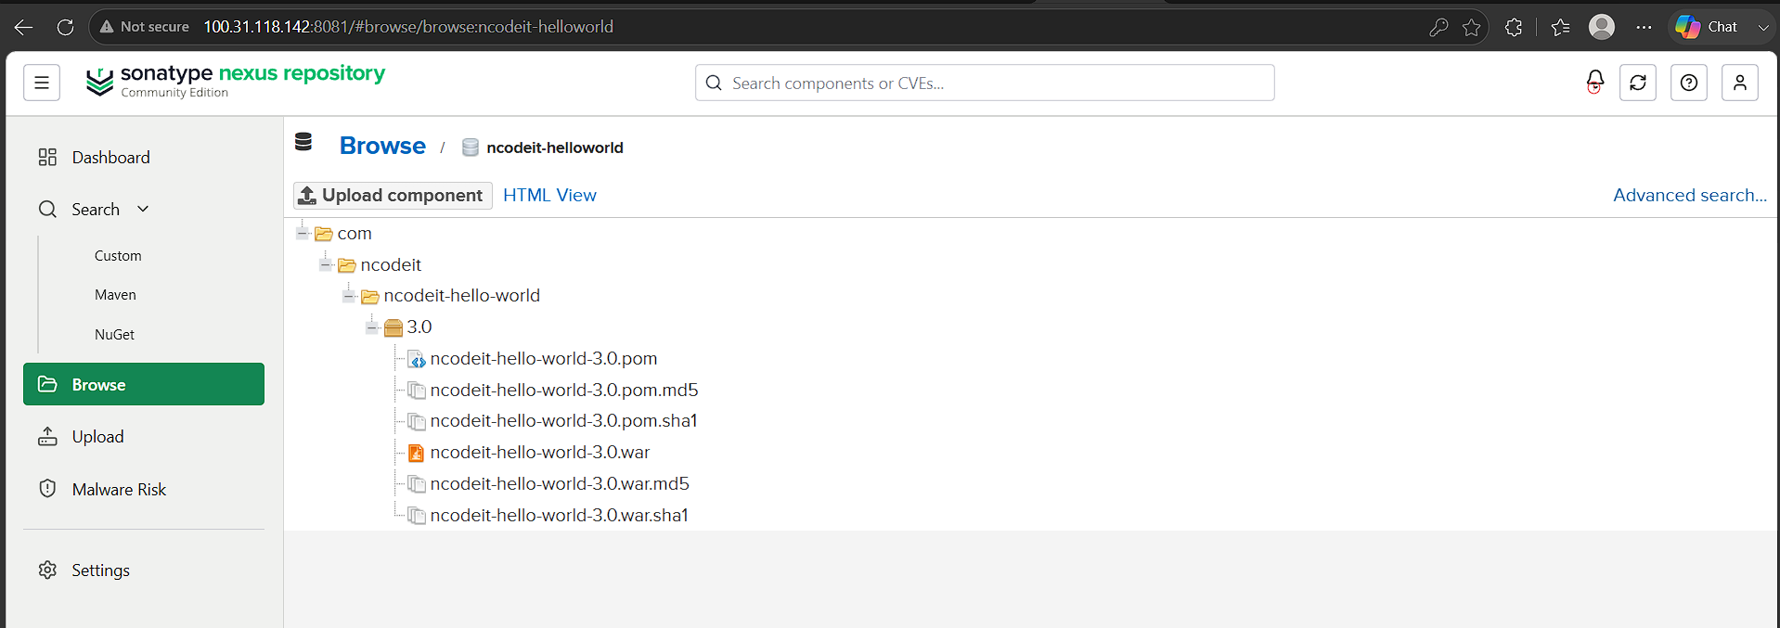
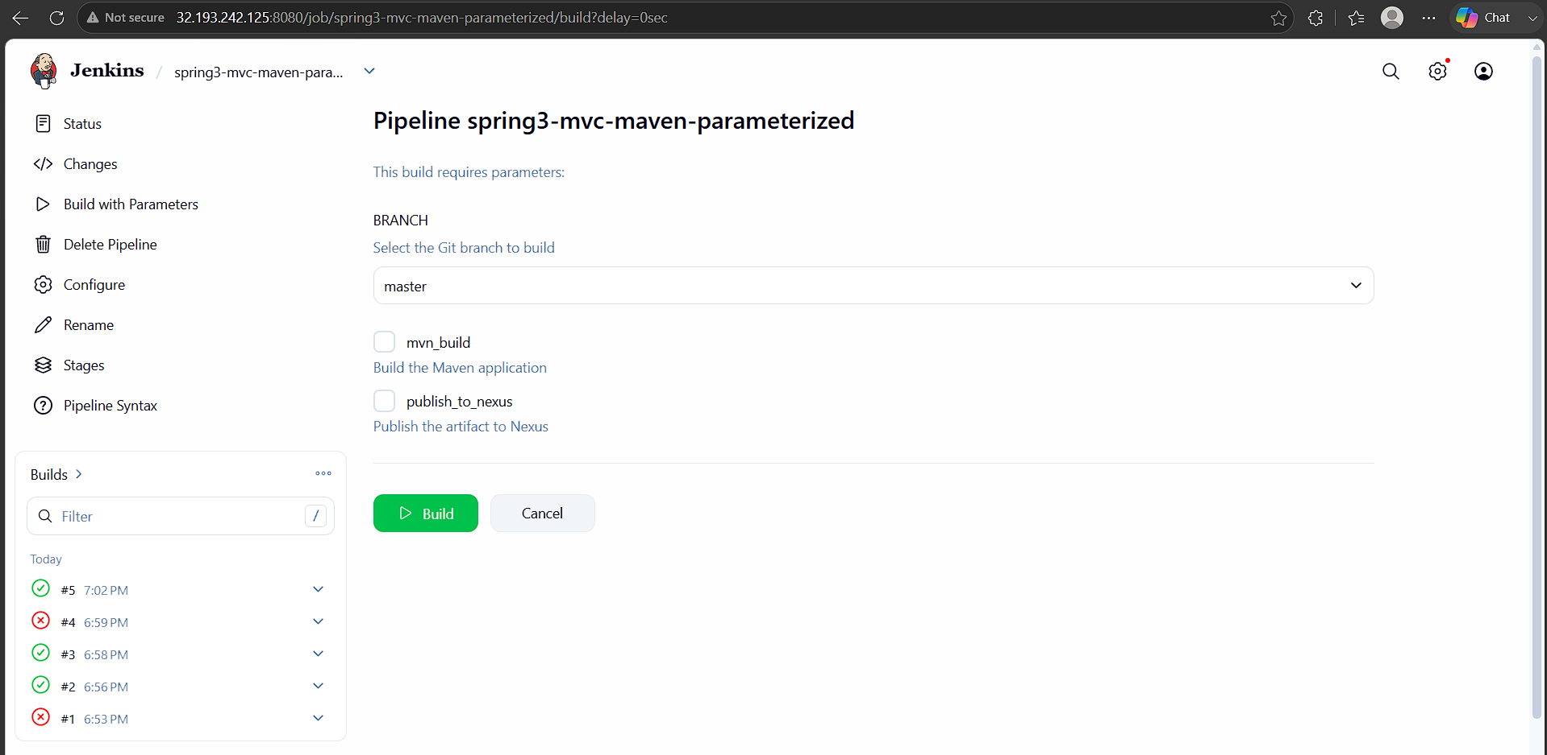

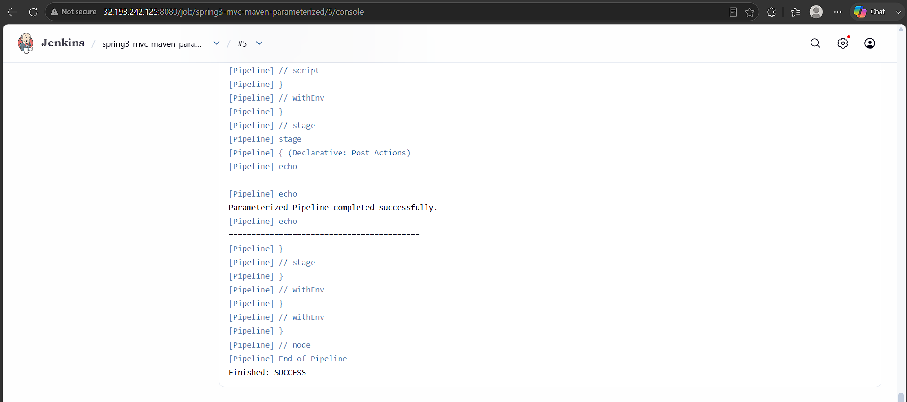
- Write sample skeleton for Declarative and Scripted pipelines

1. Declarative Pipeline — Skeleton
Declarative Pipeline uses a structured pipeline {} syntax.
pipeline {
// Where the pipeline should execute
agent any
// Input parameters
parameters {
string(
name: 'BRANCH',
defaultValue: 'master',
description: 'Git branch to build'
)
}
// Tools configured in Jenkins
tools {
maven 'MVN_HOME'
// jdk 'JDK17'
}
// Environment variables
environment {
APP_NAME = 'my-application'
ENV_NAME = 'dev'
}
// Pipeline stages
stages {
stage('Checkout') {
steps {
echo 'Checking out source code...'
git branch: "${params.BRANCH}",
url: 'https://github.com/example/project.git'
}
}
stage('Build') {
steps {
echo 'Building application...'
sh 'mvn clean package'
}
}
stage('Test') {
steps {
echo 'Running tests...'
sh 'mvn test'
}
}
stage('Deploy') {
steps {
echo 'Deploying application...'
sh 'echo Deploy application'
}
}
}
// Actions after pipeline completion
post {
always {
echo 'Pipeline execution completed.'
}
success {
echo 'Pipeline completed successfully.'
}
failure {
echo 'Pipeline failed.'
}
}
}
Declarative structure
pipeline
│
├── agent
├── parameters
├── tools
├── environment
│
├── stages
│ ├── stage
│ │ └── steps
│ ├── stage
│ │ └── steps
│ └── stage
│ └── steps
│
└── post
├── always
├── success
└── failure

2. Scripted Pipeline — Skeleton
Scripted Pipeline is more flexible and uses Groovy programming constructs directly.
node {
// Variables
def mvnHome
try {
stage('Preparation') {
echo 'Preparing environment...'
// Checkout source code
git branch: 'master',
url: 'https://github.com/example/project.git'
// Get Maven tool configured in Jenkins
mvnHome = tool 'MVN_HOME'
}
stage('Build') {
echo 'Building application...'
sh "${mvnHome}/bin/mvn clean package"
}
stage('Test') {
echo 'Running tests...'
sh "${mvnHome}/bin/mvn test"
}
stage('Deploy') {
echo 'Deploying application...'
sh 'echo Deploy application'
}
echo 'Pipeline completed successfully.'
}
catch (Exception e) {
echo "Pipeline failed: ${e}"
currentBuild.result = 'FAILURE'
throw e
}
finally {
echo 'Pipeline execution completed.'
}
}
Scripted structure
node
│
├── variables
│
├── try
│ │
│ ├── stage
│ │ └── steps
│ │
│ ├── stage
│ │ └── steps
│ │
│ └── stage
│ └── steps
│
├── catch
│ └── error handling
│
└── finally
└── cleanup
Declarative vs Scripted
Feature | Declarative | Scripted
Basic syntax | pipeline {} | node {}
Structure | Strict | Flexible
Learning | Easier | More difficult
Groovy coding | Limited | Extensive
stages | Required | Optional convention
post | Built-in | Usually try/catch/finally
when | Built-in | Use if/else
Parameters | parameters {} | properties() / params
Complex logic | Possible | Excellent
Recommended for | Standard CI/CD | Complex workflows
Easy way to remember for interviews
Declarative:
pipeline {
agent
parameters
environment
stages
post
}
Scripted:
node {
variables
stage {
steps
}
try {
...
}
catch {
...
}
finally {
...
}
}
In short: Declarative Pipeline is structured and easier to maintain, while Scripted Pipeline provides greater Groovy flexibility and control.

- Create one Declarative job
Source Code:https://github.com/betawins/sabear_simplecutomerapp/tree/feature-1.1

Jenkinsfile
pipeline {
agent any
tools {
// Note: this should match with the tool name configured in your jenkins instance (JENKINS_URL/configureTools/)
maven "MVN_HOME"

}
environment {
// This can be nexus3 or nexus2
NEXUS_VERSION = "nexus3"
// This can be http or https
NEXUS_PROTOCOL = "http"
// Where your Nexus is running
NEXUS_URL = "100.31.118.142:8081/"
// Repository where we will upload the artifact
NEXUS_REPOSITORY = "simple-customer-app"
// Jenkins credential id to authenticate to Nexus OSS
NEXUS_CREDENTIAL_ID = "nexus-credentials"
SCANNER_HOME = tool 'sonar_scanner'
}
stages {
stage("clone code") {
steps {
script {
// Let's clone the source
git 'https://github.com/betawins/sabear_simplecutomerapp.git';
}
}
}
stage("mvn build") {
steps {
script {
// If you are using Windows then you should use "bat" step
// Since unit testing is out of the scope we skip them
sh 'mvn -Dmaven.test.failure.ignore=true clean install'
}
}
}
stage('SonarCloud') {
steps {
withSonarQubeEnv('sonarqube') {
sh '$SCANNER_HOME/bin/sonar-scanner \
-Dsonar.projectKey=Ncodeit \
-Dsonar.projectName=Ncodeit \
-Dsonar.projectVersion=2.0 \
-Dsonar.sources=/var/lib/jenkins/workspace/$JOB_NAME/src/ \
-Dsonar.binaries=target/classes/com/visualpathit/account/controller/ \
-Dsonar.junit.reportsPath=target/surefire-reports \
-Dsonar.jacoco.reportPath=target/jacoco.exec \
-Dsonar.java.binaries=src/com/room/sample '

}
}
}
stage("publish to nexus") {
steps {
script {

echo "Reading Maven project information..."

def groupId = sh(
script: "mvn help:evaluate -Dexpression=project.groupId -q -DforceStdout",
returnStdout: true
).trim()

def artifactId = sh(
script: "mvn help:evaluate -Dexpression=project.artifactId -q -DforceStdout",
returnStdout: true
).trim()

def packaging = sh(
script: "mvn help:evaluate -Dexpression=project.packaging -q -DforceStdout",
returnStdout: true
).trim()

def pomVersion = sh(
script: "mvn help:evaluate -Dexpression=project.version -q -DforceStdout",
returnStdout: true
).trim()

echo "Group ID : ${groupId}"
echo "Artifact ID : ${artifactId}"
echo "Packaging : ${packaging}"
echo "Version : ${pomVersion}"

// Find WAR
def artifactPath = sh(
script: "find target -maxdepth 1 -type f -name '*.war' | head -1",
returnStdout: true
).trim()

if (!artifactPath) {
error "WAR file was not found in target directory"
}

echo "Artifact: ${artifactPath}"

if (!fileExists(artifactPath)) {
error "Artifact does not exist: ${artifactPath}"
}

echo "Uploading artifact to Nexus..."

nexusArtifactUploader(
nexusVersion: NEXUS_VERSION,
protocol: NEXUS_PROTOCOL,
nexusUrl: NEXUS_URL,
groupId: groupId,
version: pomVersion,
repository: NEXUS_REPOSITORY,
credentialsId: NEXUS_CREDENTIAL_ID,
artifacts: [
[
artifactId: artifactId,
classifier: '',
file: artifactPath,
type: packaging
],
[
artifactId: artifactId,
classifier: '',
file: "pom.xml",
type: "pom"
]
]
)

echo "=========================================="
echo "Successfully uploaded to Nexus"
echo "=========================================="
}
}
}
}
}

- Jenkins → New Item
- Name:
simple-customer-app-declarative
- Select Pipeline
- Click OK
- Under Pipeline → Definition, select Pipeline script
- Paste the Jenkinsfile above.
- Save

The pipeline should perform:
Checkout
↓
Maven Build
↓
Verify WAR
↓
Archive WAR
↓
SUCCESS
The repository's POM identifies the project as com.javatpoint:SimpleCustomerApp, packaging it as a WAR and using Java 8 source/target settings.
The artifact version is based on the POM's ${BUILD_NUMBER}-SNAPSHOT, so Jenkins build 10 will produce:
SimpleCustomerApp-10-SNAPSHOT.war
The original repository Jenkinsfile also uses Maven, SonarQube, and Nexus publishing.

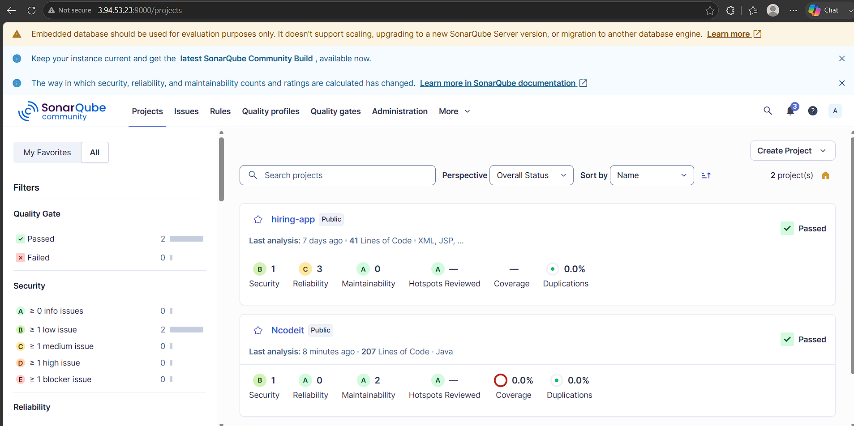
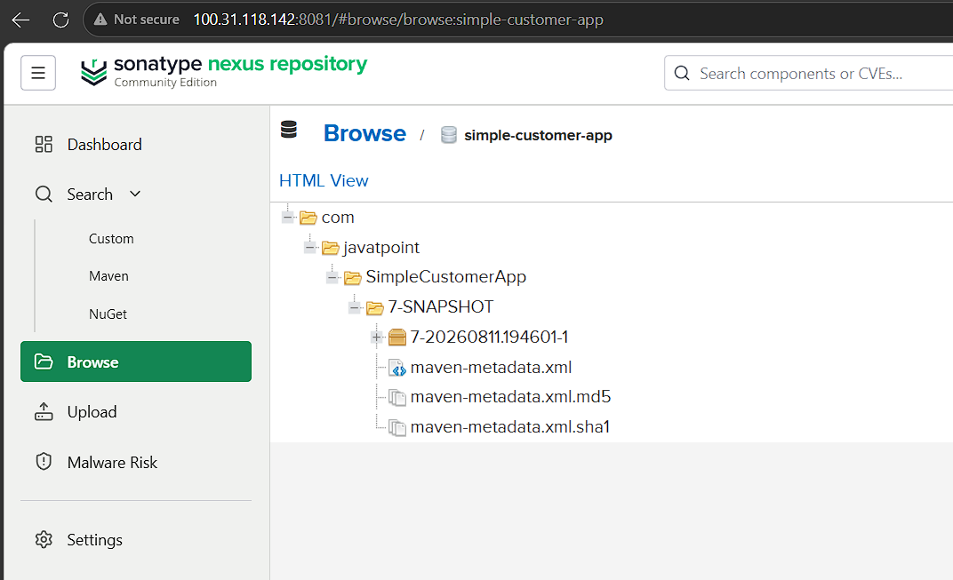
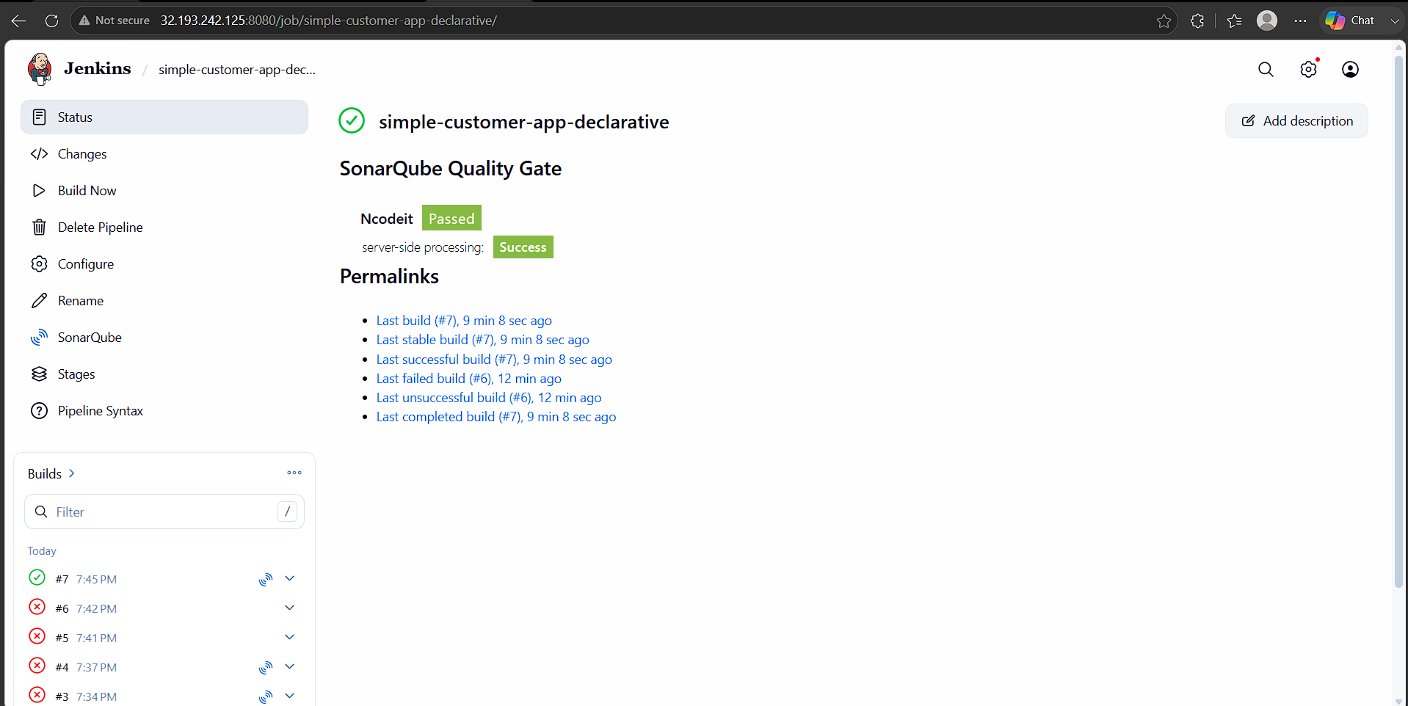
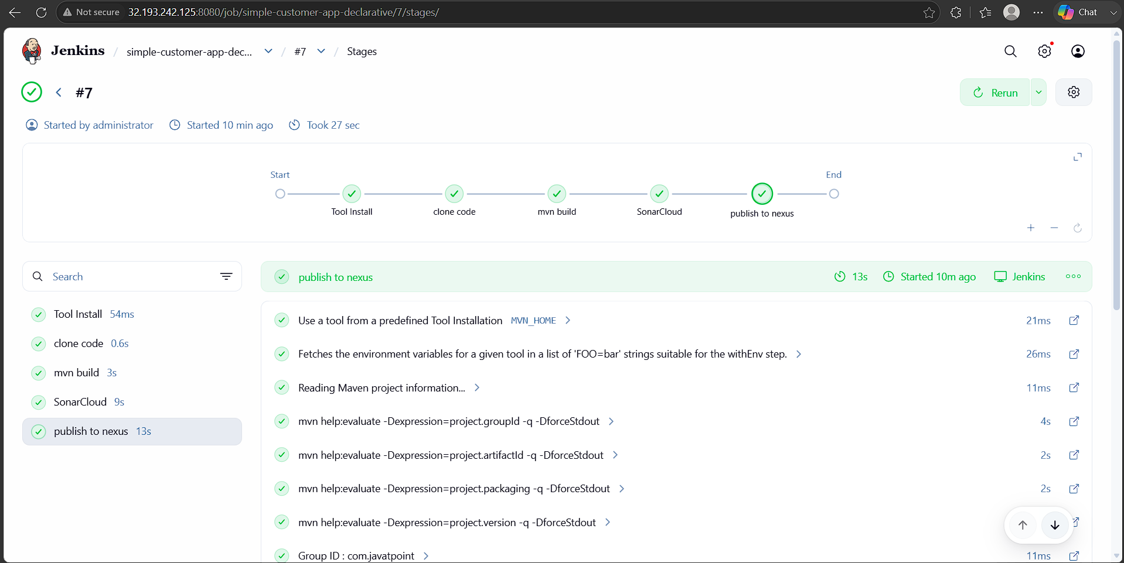

- Create one Declarative job
Source Code:https://github.com/betawins/Trading-UI.git
pipeline {
agent any

environment {
IMAGE_NAME = "trading-ui"
CONTAINER_NAME = "trading-ui"
PORT = "3000"
}

stages {
stage('Checkout') {
steps {
checkout scm
}
}

stage('Build Docker Image') {
steps {
script {
echo "Building Docker image..."
sh "docker build -t ${IMAGE_NAME}:latest ."
}
}
}

stage('Deploy') {
steps {
script {
echo "Deploying container..."

// Stop and remove old container if exists
sh """
docker stop ${CONTAINER_NAME} || true
docker rm ${CONTAINER_NAME} || true
"""

// Run new container
sh """
docker run -d \
--name ${CONTAINER_NAME} \
-p ${PORT}:3000 \
--restart unless-stopped \
${IMAGE_NAME}:latest
"""
}
}
}
}

post {
success {
echo "✅ Deployment successful! App running on port ${PORT}"
}
failure {
echo "❌ Build or Deployment failed"
}
}
}

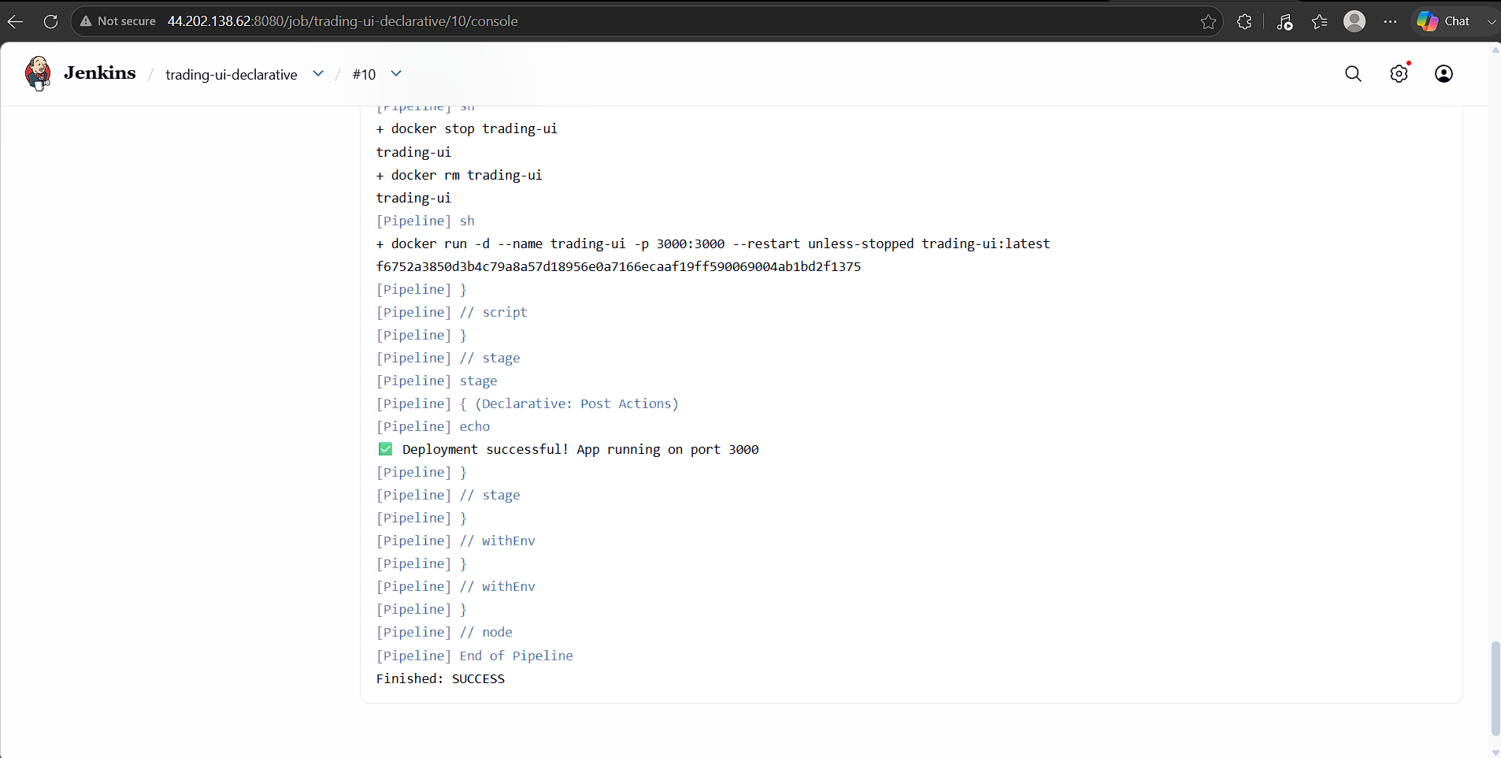

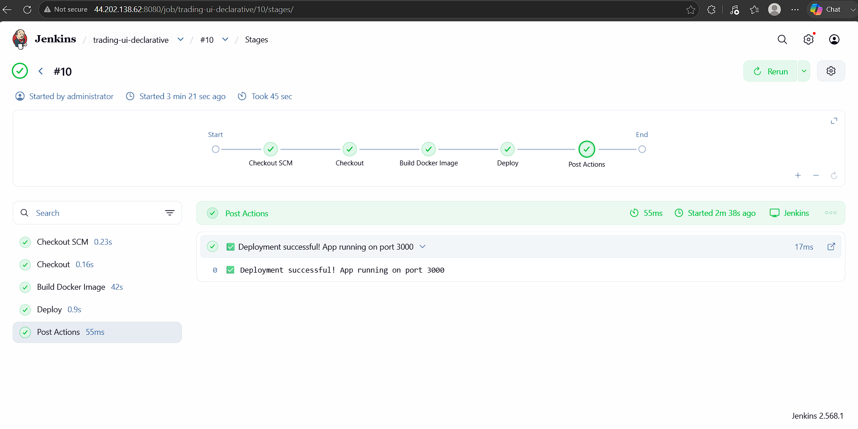

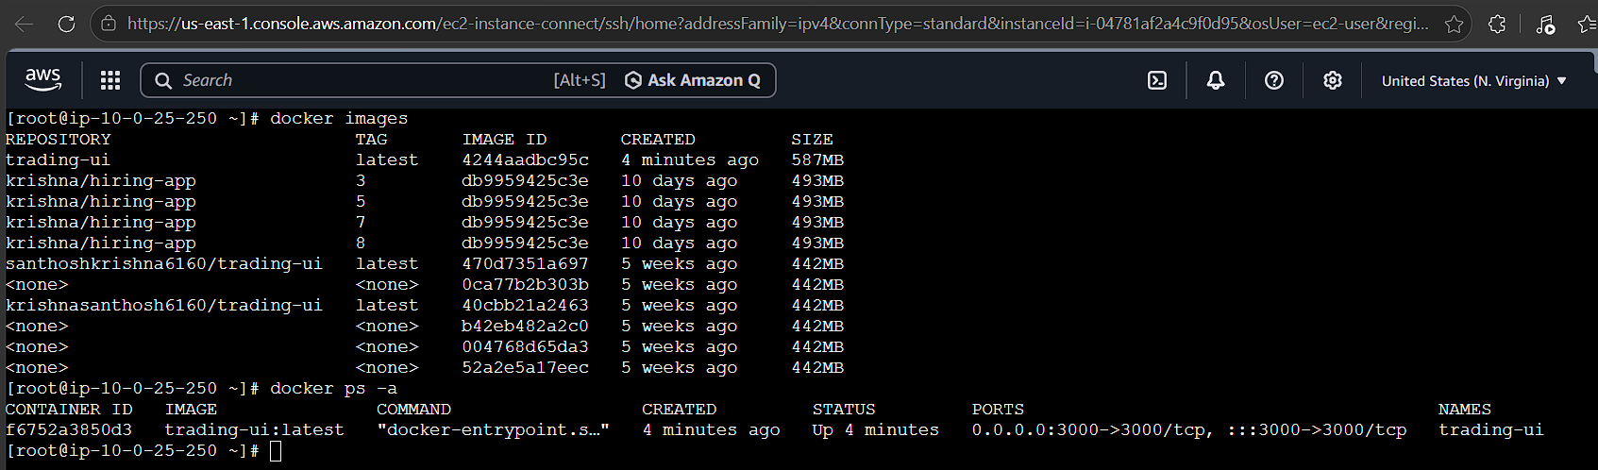

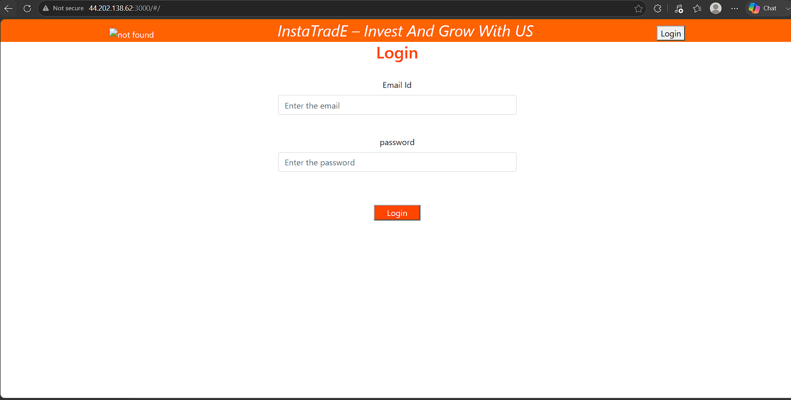

7. Execute parallel stages using Jenkins pipeline for any sample job

Steps:
• Created an ec2-instance, My-ec2-jenkins with instance type, c7i.flex.large, default security group.
• Installed java-21 in this instance as it is a prerequisite for Jenkins
• Installed Jenkins & connected with ipv4 & port 8081
• Installed plugins & changed the admin password
• Created an ec2 instance, My-ec2-docker_sonarqube with docker installed, sonarqube & tomcat installed in My-ec2-docker_tomcat
• Installed the sonarqube_scanner, maven, nexus artifactory uploader & Deploy to container plugins & done the configuration in settings, Tools with the valid credentials in Jenkins GUI.
• Now in GUI create a new job, Parallel_stage_pipeline selecting job as pipeline & create
• In configure, pipeline write the below declarative pipeline code to integrate & deploy to tomcat application.
• Now click build now
• Capture the console output once the job is success
• The job has passed the checks, compiled by maven & war file is stored in nexus repository & deployed to tomcat & slack notification received for job success/failure.

pipeline {
agent any

environment {
IMAGE_NAME = "trading-ui"
CONTAINER_NAME = "trading-ui"
PORT = "3000"
GIT_URL = "https://github.com/krishnasanthosh6160/Trading-UI.git"
GIT_BRANCH = "master"
}

stages {

stage('Checkout') {
steps {
echo '======================================'
echo 'Checking out Trading-UI source code'
echo '======================================'

git branch: "${GIT_BRANCH}",
url: "${GIT_URL}"
}
}

stage('Parallel Checks') {

parallel {

stage('Node and NPM Check') {
steps {
echo '======================================'
echo 'Node.js and NPM Check'
echo '======================================'

sh '''
echo "Node version:"
node --version

echo "NPM version:"
npm --version

echo "Node location:"
which node

echo "NPM location:"
which npm
'''
}
}

stage('Docker Environment Check') {
steps {
echo '======================================'
echo 'Docker Environment Check'
echo '======================================'

sh '''
echo "Docker version:"
docker --version

echo "Docker info:"
docker info > /dev/null

echo "Docker service is available."
'''
}
}

stage('Install Dependencies') {
steps {
echo '======================================'
echo 'Installing NPM Dependencies'
echo '======================================'

sh '''
npm install
'''
}
}
}
}

stage('Build Docker Image') {
steps {
script {
echo '======================================'
echo 'Building Trading-UI Docker Image'
echo '======================================'

sh """
docker build -t ${IMAGE_NAME}:latest .
"""
}
}
}

stage('Deploy') {
steps {
script {

echo '======================================'
echo 'Deploying Trading-UI Container'
echo '======================================'

sh """
docker stop ${CONTAINER_NAME} || true
docker rm ${CONTAINER_NAME} || true
"""

sh """
docker run -d \
--name ${CONTAINER_NAME} \
-p ${PORT}:3000 \
--restart unless-stopped \
${IMAGE_NAME}:latest
"""

echo "Container deployed successfully."
}
}
}

stage('Verify Deployment') {
steps {
echo '======================================'
echo 'Verifying Docker Container'
echo '======================================'

sh '''
docker ps

echo "Testing application..."
curl -I --connect-timeout 10 http://localhost:3000 || true
'''
}
}
}

post {

success {
echo '======================================'
echo 'Trading-UI Pipeline SUCCESS'
echo '======================================'
echo "Application running on port ${PORT}"
}

failure {
echo '======================================'
echo 'Trading-UI Pipeline FAILED'
echo '======================================'
}

always {
echo '======================================'
echo 'Pipeline execution completed.'
echo '======================================'
}
}
}

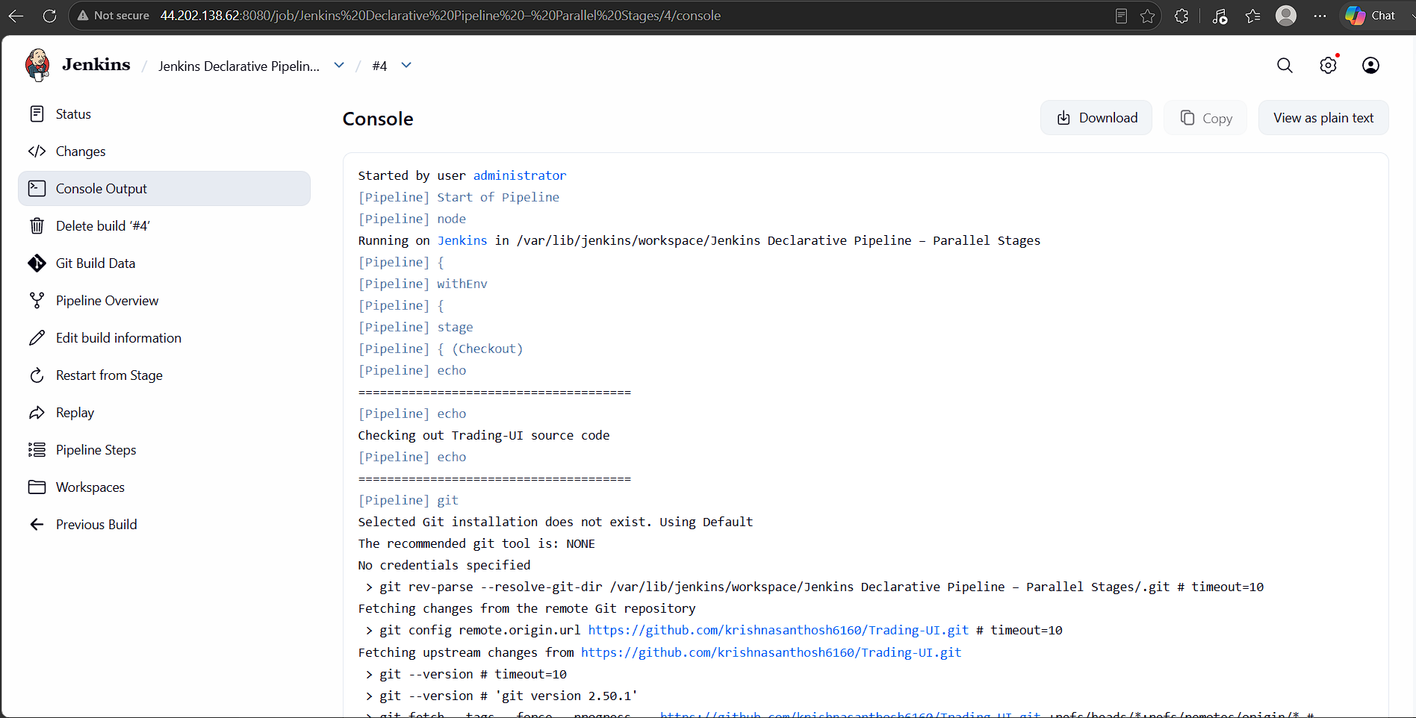

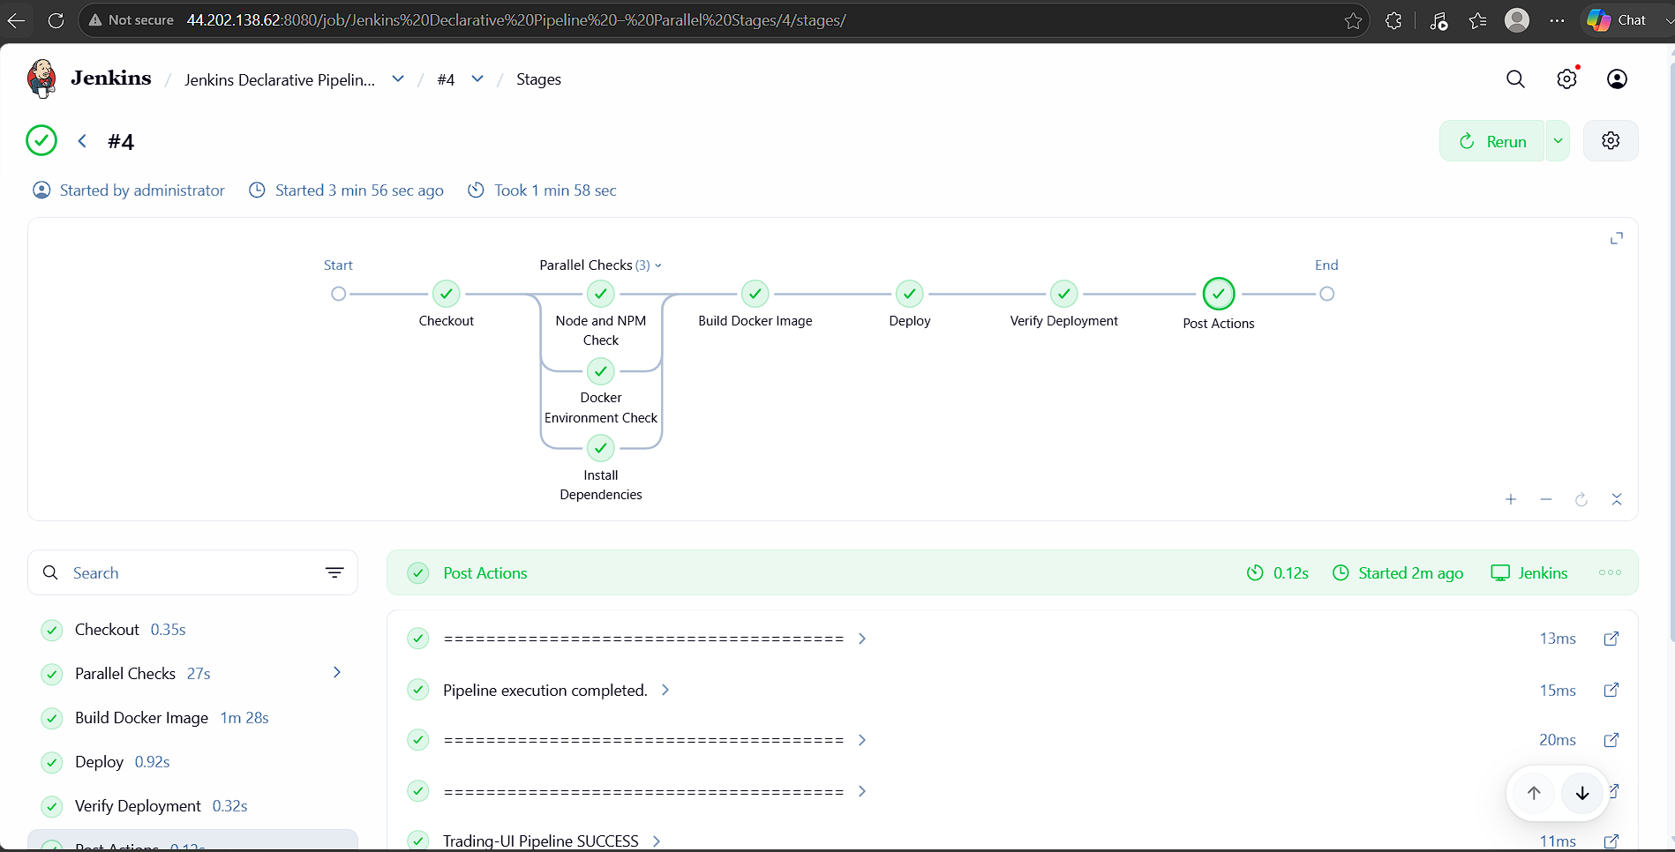

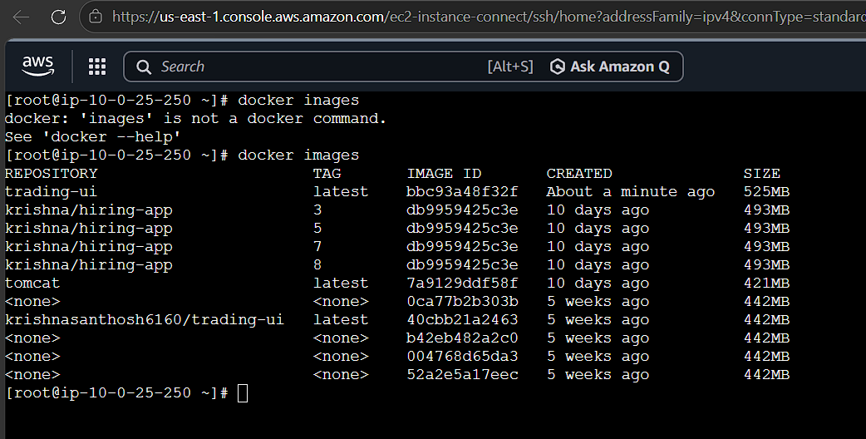



8. Execute Jenkins pipeline stages using shared libraries
- Reference:https://phoenixnap.com/kb/jenkins-shared-library

Objective
Implement reusable Jenkins pipeline stages (Build, Test, Deploy, Notification) using a Jenkins Shared Library stored in GitHub.
Prerequisites
Jenkins installed
Git plugin
Pipeline plugin
Maven installed and configured in Manage Jenkins → Tools
GitHub account
Slack plugin (optional)
Repository Structure
1. Shared Library Repository
Example repository:
Jenkins_shared_lib
│
├── vars
│ ├── buildApp.groovy
│ ├── testApp.groovy
│ ├── deployApp.groovy
│ └── notifySlack.groovy
│
├── src
│
└── README.md

2. Application Repository
Repository:
sabear_simplecutomerapp
│
├── pom.xml
├── src
├── Jenkinsfile
└── README.md
Steps:
- Configure Shared Library in Jenkins,
Manage Jenkins
↓
System
↓
Global Trusted Pipeline Libraries
Configure:
Property | Value
Name | Jenkins_shared_lib
Default Version | master
Retrieval Method | Modern SCM
SCM | Git
Repository URL | https://github.com/betawins/Jenkins_shared_lib.git (or your actual shared library repository)

- In local machine create the below:
Create Shared Library Functions
buildApp.groovy

Location:
vars/buildApp.groovy
def call() {
echo "Building Application..."
sh 'mvn clean package'
}

testApp.groovy
def call() {
echo "Running Tests..."
sh 'mvn test'
}

deployApp.groovy
def call() {
echo "Deploying Application..."
}

notifySlack.groovy
def call(String message) {
slackSend(
channel: '#all-ashraff',
color: 'good',
message: message
)
}
- Now push to git hub
git init
git add .
git commit -m "Initial Shared Library"
git remote add origin https://github.com/ashraff452/jenkins-shared-library.git
git push -u origin main
- Now create a shared-lib job in Jenkins ui with the below pipeline code:
@Library('Jenkins_shared_lib@master') _

pipeline {

agent any

tools {
maven 'maven'
}

stages {

stage('Checkout') {
steps {
git branch: 'feature-1.1',
url: 'https://github.com/betawins/sabear_simplecutomerapp.git'
}
}

stage('Build') {
steps {
buildApp()
}
}

stage('Test') {
steps {
testApp()
}
}

stage('Deploy') {
steps {
deployApp()
}
}
}

post {

success {
notifySlack("Application deployed successfully.")
}

failure {
notifySlack("Pipeline failed.")
}
}
}
- Now click build now & once the job is successful we can see in console output

